DIGITEK SYSTEM INTERNATIONAL INC DYNAMIC BUSINESS SOLUTION
Screen L*W mm | 128*64 LCD
Identification time | <1s
Fingerprint Capacity | 3,000
Log Capacity | 80,000
Temperature | 0c-50C
Power | DC9V
Voltage range | 150v~240V
FAR | ≤0.0001%
FRR | ≤1%
Language | English
Communication Protocols | TCP/IP (Optional), RS232/485, USB, U-disc
Display | Colored TFT
Machine size (L*W*H mm) | 178*128*50 mm
Packing (L*W*H cm) | 270*180*120
Optional Function | TCP/IP ID or IC card  Back-up battery, can work for couple of hours without power

PRESENTS

DTK 500 T

PARAMETERS

KEY FEATURES

Korean design , Data transfer through Pendrive , TCP/IP as well as USB plug & play connectivity, Battery backup (optional),3,000 users , Very fast Identity system, Scratch less & dust free Sensor , SDK available, Colored display, CE & ROHS certified.

About Digitek System International INC –
DIGITEK is Korea based company & is leader in Biometric solution, In a world of digital revolution, where the technology is reaching out and touching our lives in almost every sphere, DIGITEK has emerged as a leading supplier of end-to-end solutions for the technology platforms of Smart Cards, Biometrics, Radio Frequency Identification and IP Surveillance. Digitek innovative and most outstanding biometric solutions for corporate and organizations across the system. DIGITEK is uniquely focused on delivering Biometric security based enterprise-wide applications designed from ground up for the SME and Large market. These applications are extremely cost effective, feature-rich and user friendly. Users can start with an off-the-shelf

office

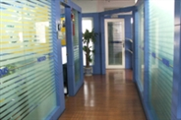
R&D center
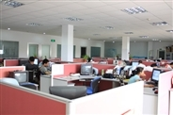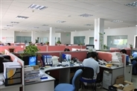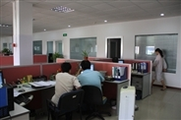

production line
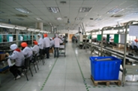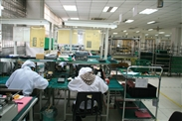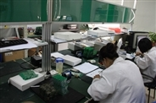

SMT
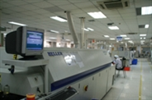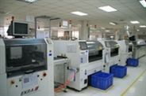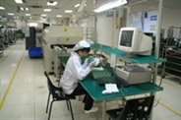

DYNAMIC BUSINESS SOLUTION
K-37/1 , Krishna park ext,
Street no -13, Tilaknagar,NewDelhi-18
Ph-+91-11-25990231
www.dbsindia.in

