ZK Softwares USA

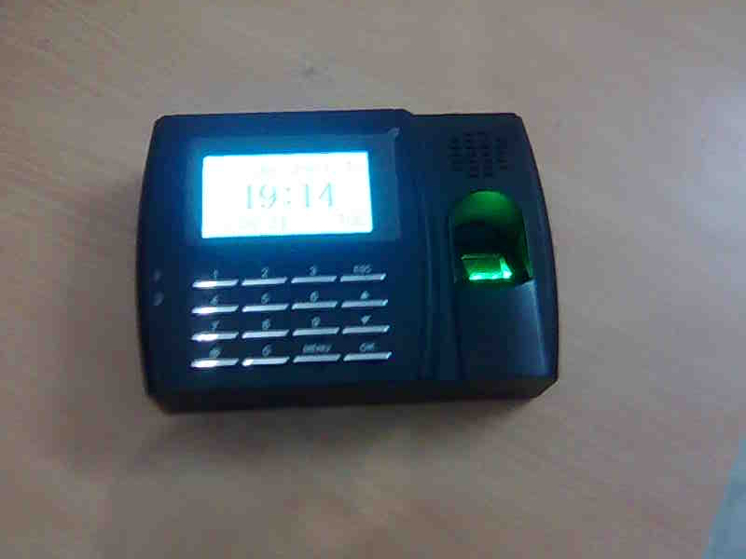
Product Introduction
U 300 is a standalone fingerprint T&A system. It is built in Linux operation system and DP UrU4000 sensor. The identification speed is fast and FFR and FAR are low. Memory stick solves the problem of no PC in local site. You just download records into the stick and take it to where there is PC.
Benefits -
2009 Version of algorithms with dependability and accuracy, identification speed obviously improved, it can manage 6000 fingerprint templates within 2 sec.
Built in embedded standalone module (ZEM200) with strong American Intel 32 bit X-scale CPU
Adopt U.are.U. U sensor, improving fingerprint identification.
Support 360-degree rotation identification, easy to use and reliable.
Sensor window cotton improved image quality, access dry/wet fingers.
Automated exposure and intelligent compensation improved image quality
Technical Specification -
Size 184(L)142(W) 50(H)mm
User capacity 6,000, Transaction – 1,00,000
Algorithm version 2009 Version ZKXC new algorithm
Hardware platform ZEM200
Operating system Linux
Communications RS232 RS485 TCP/IP Standard
Identification time <=2s
FAR <=0.0001%
FRR<=1%
LED Red Green

Mfgs Office - Indian sales & service –
ZK Software (USA) Inc. Dynamic Business Solution
Address: Adress-
505 8th Ave., Suite 1004 K-37/1 Krishna Park Extension,
New York, NY 10018 Street no -13, Tilaknagar,
United States New Delhi - 18
Phone: +1 212-991-0090 | Phone: +91 9891472108
Fax: +1 212-268-4858
Website: www.zk-usa.com | Website: www.dbsindia.in

